**Writeup for Let’s play a game**

**Description** : Maybe you can buy some points to get the flag…

**Given file** : 575TY6.mp3

From the audio file we can hear a conversation between two person. We can extract few information from the audio like Sergeant Garrick, John McTavish, Simon Riley, Task Force 141. Searching for the google we can find this.

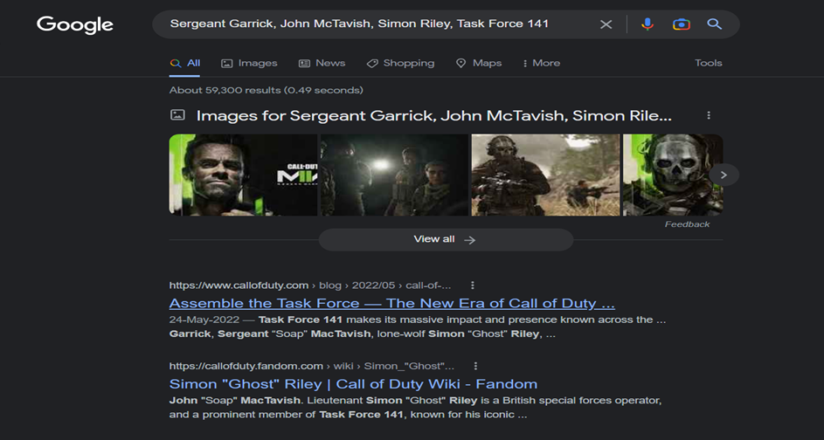

We can see the names are from the game Call of Duty. As the description says “maybe you can buy some points to get the flag….” we can assume that buying points can give us the flag.

Buying points refers to buying the in-game currency of call of duty also referred to as CP. Searching for the same on google we can find few websites offering the CPs. One such being codashop.com.

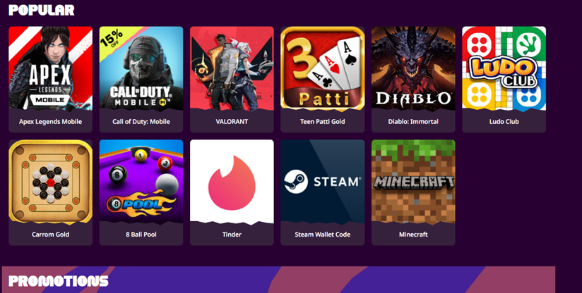

We can find variety of games, opting for call of duty…

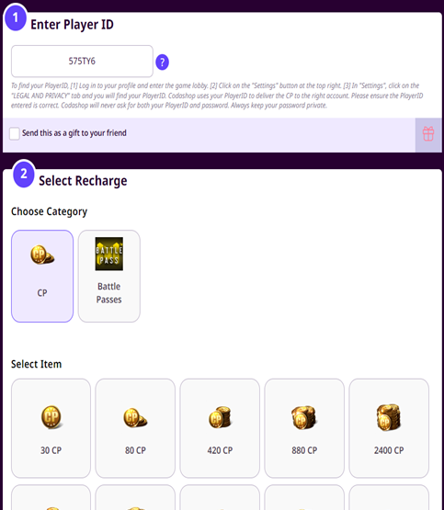

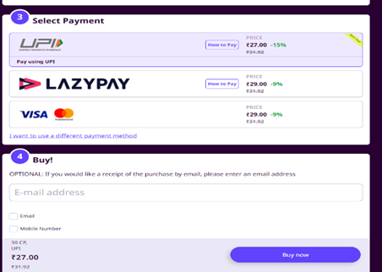

A player ID is 6 character ID and we can see the name of the audio file is given as 575TY6 is also 6 character we can assume it to be the player ID, selecting appropriate CP value and payment method and clicking on buy now gives a confirmation message with some details.

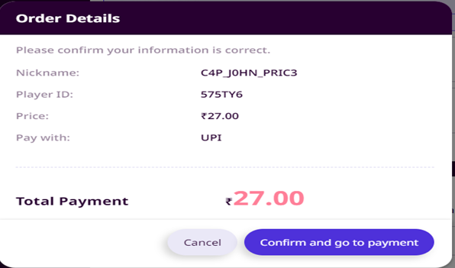

We can see the nickname is of the format of the flag. The flag is vishwaCTF{C4P_J0HN_PRIC3}